**INT 217 PROJECT REPORT**

(Project Semester August-December 2019)



***DATA ANALYSIS ON***

**SEX RATIO OF INDIA (2001-11)**

**Submitted by**

**Shyam Jat**

**Registration No.: 11715782**

**Programme: B.Tech (CSE)**

**Section: K17yp**

**Course Code: INT 217**

**Under the Guidance of**

**Ms. Maneet Kaur**

**Discipline of CSE/IT**

**Lovely School of Technology**

**Lovely Professional University, Phagwara**

**DECLARATION**

I, Shyam Jat student of B.Tech under CSE/IT Discipline at, Lovely Professional University, Punjab, hereby declare that all the information furnished in this project report is based on my own intensive work and is genuine.

Date: 11 Nov 2019

Signature

Registration No. 11715782

**CERTIFICATE**

**This is to certify that Shyam Jat bearing Registration no. 11715782 has completed INT 217 project titled, “Sex Ratio of India (2001-2011)” under my guidance and supervision. To the best of my knowledge, the present work is the result of his/her original development, effort and study.**

**Signature and Name of the Supervisor**

**Designation of the Supervisor**

**School of Technology**

**Lovely Professional University**

**Phagwara, Punjab.**

**Date: 11 November 2019**

**ACKNOWLEDGEMENT**

**The success and final outcome of this project required a lot of guidance and assistance from many people and I am extremely privileged to have got this all along the completion of my project. All that I have done is only due to such supervision and assistance and I would not forget to thank them.**

**I would like to express my deepest appreciation to all those who provided me the possibility to complete this report.  A special gratitude I give to my classmates, whose contribution in stimulating suggestions and encouragement, helped me to coordinate my project especially in writing this report.**

**I respect and thank Ms. Maneet Kaur, for providing me an opportunity to do the project work in Lovely Professional University and giving us all support and guidance which made me complete the project duly. I am extremely thankful to him for providing such a nice support and guidance, although he had busy schedule managing the corporate affairs.**

**I am thankful to and fortunate enough to get constant encouragement, support and guidance from all Teaching staffs of which helped us in successfully completing our project work. Also, I would like to extend our sincere esteems to all staff in laboratory for their timely support.**

**Sincerely**

**Shyam Jat**

**TABLE OF CONTENTS**

**CONTENTS PAGE NO.**

**1.) Introduction ……………………………………………………………. 06**

**2.) Scope of the Analysis…………………………………………………... 07**

**3.) Existing System ………………………………………………………… 08**

**Drawbacks or limitations of existing system……………………….09-13**

**4.) Source of dataset………………………………………………………… 14**

**5.) ETL process………………………………………………………………..15**

**6.) Analysis on dataset (for each analysis) Introduction……………………16-30**

1. **General Description**
2. **Specific Requirements, functions and formulas**
3. **Analysis results**
4. **Visualization**

**7.) List of Analysis with results…………………………………………………32-33**

**8.) Future scope…………………………………………………………………34**

**9.) Reference………………………………………………………………........ 35**

**10.) Bibliography ……………………………………………………………….36**

**INTRODUCTION**

Sex ratio of human population is one of the basic demographic characteristics, which is extremely vital for any meaningful demographic analysis. Indian census has the tradition of bringing out disaggregated information by sex on various aspects of population. Primarily it is the simple count of males and females. Many socio-economic relationships intimately related to the balance or disparity between the number of males and females. Changes in sex composition largely reflect the underlying socio-economic and cultural patterns of a society in different ways.

Sex composition of population is one of the key factors in a country’s development and has both demographic and social implications. The proportion of males and females in the population affect the social and economic relationships within a region. Further data for sex ratio helps in various types of planning and for the analysis of other demographic indicators like fertility, mortality, migration and economic structure.

Of all the demographic attributes of population, the sex structure is one of the most fundamental and directly related to the reproductive potential of the humankind, deaths and marriages (United Nations, 1973).

It is a biological fact that more males are born than females. This does not mean that all the regions have similar natural sex ratio. Males have dominated sex ratio for population of India since long. In 1901, sex ratio for India was 972 females per thousand males, since then the number of females consistently declined except for few decades, so that in 2001, sex ratio for India reached at 933 females per thousand males. In India, though mortality among male children is high, sex ratio does not become balanced. Infant mortality among females is higher than that among males. Likewise, maternal mortality among females is quite high. Because of inadequate attention given towards upbringing of children, mortality among female children is quite high. Besides, due to high maternal mortality, life expectancy of females is low. Among those dying due to epidemic diseases, and due to inadequate medical facilities, proportion of female is quite high. Their number in total population declines because of these reasons.

In this project, the attempt is made to provide an understanding of the spatio-temporal trends in the sex ratio of human population in the study region and its fluctuation over decades along with the comparative analysis of India, the state of Maharashtra and the study region. All the relevant data required for the purpose taken from the Census of India 2001 and 2011.

**SCOPE OF THE ANALYSIS**

Over all sex ratio (OSR) in India has enlarged from the last census (2001) by seven points from 933 to 940, the situation is worse for the child sex ratio (CSR). According to the decadal Indian census, the sex ratio in the 0-6 age group went down from 962 girls per 1000 boys in 1981, to 914 girls per 1000 boys in 2011. 2011 census showed that in 26 States/UTs rural child sex ratio are higher than urban areas. The paper intends to explain variability of CSR across the country through superimposed socio cultural frame.

The analysis is based on CSR provided by Census of India for various decades. The study has focused on various factors covering wide range of socio-economic and demographic dimension that can be associated with contemporary sex discrimination and clarified their relative explanatory power. A total 230 districts has been analyzed from 7 states which have their CSR below national average (914). The spatial dimension of discrimination obtainable above leads to conclusions that sex ratio is more skewed in the most urbanized and economically well off states of north and western region.

Through this project, we will try to identify the following objectives:

(1) To study the status of sex ratio at birth with increasing birth order,

(2) To ascertain the relationship of declining sex ratio with respect to socio demographic factors.

(3) To study outlook of patient towards sex preference, willingness to determine sex of the foetus, wish to terminate the pregnancy in case of unwanted sex of the baby.

(4) To study the variations among different states.

(5) To find the correlation between factors like literacy rate on the sex ratio

(6) To study if the growth of population has any effect on the growth of the number of females per 1000 males

**EXISTING SYSTEM**

Contrary to popular perception that the deeply rooted prejudice against girls, reflected in the country’s sex ratio, is mostly present in rural areas, some of the largest cities in India – including Delhi and Mumbai – had imbalanced sex ratios in 2011, according to an analysis of government data.

In 2011, for every 1,000 boys aged 0-6 years, there were 852 girls in Mumbai, 832 girls in Delhi and 942 girls in Hyderabad, according to data put together that analyses large and openly accessible data sets on gender provided by the government of India’s office of the registrar general and census commissioner.

Data from 2011 is the latest publicly available on sex ratios of Indian cities.

The worst child sex ratio was in Mahesana (762 girls per 1,000 boys) in Gujarat, followed by Agra (772) in Uttar Pradesh (UP), Modinagar (778) in UP, and English Bazaar (781) in West Bengal (WB), data show. Bally, in WB had more girls (1,185) per 1,000 boys, as did Nagaon (1,043) in Assam, and Tambaram (1,019) in Tamil Nadu.

A normal gender ratio at birth is between 102-106 boys per 100 girls, which would be equivalent to 943-980 girls per 1,000 boys, according to a report by organisations working on gender issues. This ratio is not 1,000 boys for every 1,000 girls because it is nature’s way of balancing a higher risk of death for boys as they grow older, according to the WHO.

The child sex ratio, which is based on the number of boys and girls between 0-6 years of age registered at the time of the census, shows whether sex selection is prevalent in the country. A sex ratio less than the normal range of 943-980 girls per 1,000 boys, suggests discrimination against girls, and the presence of female infanticide, which is the killing of girls after birth, or of female foeticide, sex-selective abortion of the foetus.

An adverse child sex ratio is also reflected in the distorted gender makeup of the entire population. In 2031, India will have 936 females per 1,000 males, lower than the sex ratio in 1951 of 946 females per 1,000 males, the World Bank predicts.

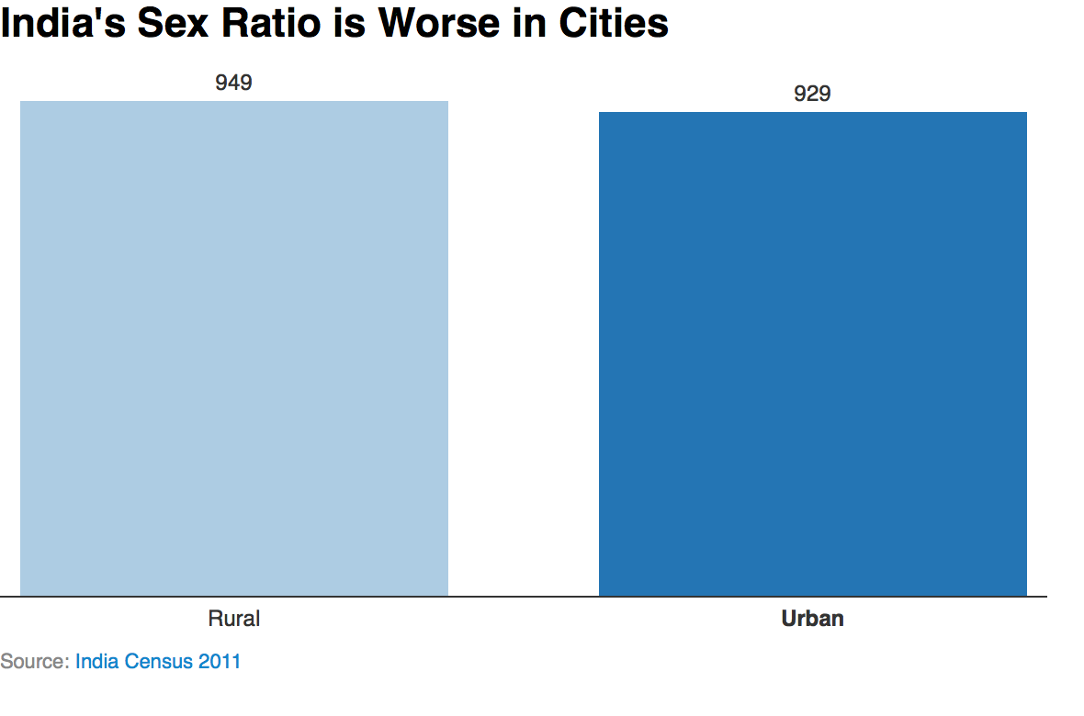

**LIMITATIONS:**

1. **How analysing city-level data could help**

Analysis, when taken down to the level of cities and towns, could help identify trends on gender discrimination which could aid the government and non-governmental organisations combat female foeticide and infanticide.

Further, research at a local level could also be used to make communities aware about the problem, and empower them to act.

Governments and organisations working on these issues could also learn from cities that have a healthy gender ratio such as Puducherry (Puducherry), Aizawl (Mizoram), Kolar (Karnataka), Kumbakonam (Tamil Nadu) and Nagercoil (Tamil Nadu).

1. **Why India’s fight against foeticide, infanticide has failed**

India’s national child gender ratio has fallen over the past three decades from 945 in 1991 to 918 per 1,000 boys in 2011, according to census data. The states of Haryana, Punjab, Jammu & Kashmir, Rajasthan, Gujarat, Uttarakhand, and Maharashtra have a ratio lower than 900 girls per 1,000, which could imperil the future gender balance and demographics of the country.

In the mid-1960s, new technology that allowed for prenatal gender determination, and thus sex-selective abortion, such as the ultrasound, was brought into India, in October 2011.

The Indian government has implemented regulations to prevent female foeticide arising because of these new technologies. One of the main laws, the Pre-Conception and Pre-Natal Diagnostic Techniques Act (PC & PNDT) of 1994 prohibits sex selection, before or after conception, and regulates diagnostic techniques to prevent misuse of sex determination techniques.

But these laws are often implemented poorly. For instance, in Maharashtra officials failed to complete 55% of inspections of sonography centres in 2014-2015, the Comptroller and Auditor General (CAG) found,

The Uttar Pradesh government has left unspent about half the funds it was allocated to curb female foeticide, according to the CAG, as reported in October 2016. None of the diagnostic centres followed all mandatory rules of preserving image records or backups taken during the ultrasonography of pregnant women, the CAG audit found. In 68% of cases, women did not even hold the necessary referral slips from their doctors.

1. **Disempowered women, culture of dowry, smaller family size might lead to sex selection**

Despite significant economic and scientific growth over the past few decades, female infanticide and foeticide remain major issues in India, data show.

Reasons for female infanticide include anti-female bias, as women are often seen as subservient to men, who often employ positions of power, according to information from the United Nations Population Fund.

In addition, parents believe they will be better taken care of in their old age by men, as men are perceived as the principal wage earners of the family. Parents of girls are usually expected to pay a dowry, which could be a massive expense, avoided by raising male

1. **Uneven Sex Ratio Pattern:**

As per a study by National Commission for Women (NOW; Delhi, Punjab and Haryana may be economically progressive but have a skewed sex ratio compared to other states. Even after immense struggles against gender discrimination a huge gender deficit continues to persist.

In the report, “Understanding Gender Equality in India 20123, a joint initiative of NCW and the UN very thought: provoking interesting facts were brought out. As per the study, interestingly, Delhi, Chandigarh and Haryana have an adverse ratio though these states are economically quite progressive.

As per capita Net State Domestic Product (NSDP), Haryana has a per capita NSDP of Rs. 78781 while Delhi and Punjab have per capita NSDP of Rs 116886 and Rs. 62153 respectively, it said.

The report also noted that the difference between the number of men and women is lesser in rural areas than in urban India, with the former being pegged at 919 women for every 1000 men and the latter 902 per 1000. The worst hit district is Haryana’s Jhajjar with a ratio of 774 to 1000 and next is Mahendragarh with a sex ratio of 778 females to 1000 males.

The states and Union Territories showing a negative trend in Census 2011 are Jammu & Kashmir (1.01 %) Daman and Diu (4.56 %) and Dadra and Nagar Haveli (12.96 %). The Census 2011 report even reflects that some of the major parts of India are at an alarming position.

So strong is the biological advantage for girls in early childhood that higher mortality among girls should be seen as “a powerful warning that differential treatment or access to resources is putting girls at a disadvantage.

1. **Reasons for Declining Sex Ratio:**

There are multiple factors behind the trend of declining sex ratio. Sex selection and medical technology is misused in India for detecting the sex of unborn child and ultimately for the) sex selection, Female foetuses, thus identified and aborted.

Many studies have shown that Pre Natal Sex Determination is the main reason of low sex ratio in India followed by abortion of female foetuses. Besides the misuse of the technology, the patriarchal societies in many parts of India have translated their prejudice and bigotry into a compulsive preference for boys and discriminations against the girl child.

Women work is always socially devalued with limited autonomy in decision making. Patriarchy always maintains a strong hold on the gender inequality. (Sex determination tests are seen as providing a ‘reproductive choice’ – a choice to decide to have a boy or a girl. Soon after the sex determining techniques, in 1983 Indian parliament banned the practice of sex determination in all public institutions. But the prime legislation Pre-Natal Diagnostic Techniques act, passed in 1994, after a long campaign by the civil society and women organisation and certain.

The law is enforced at both the national and regional levels. At the same time, many difficulties and loopholes in the provisions of the Act lead to unsatisfactory results like lack of resources to carry out inspection and monitoring, lack of corresponding qualified staff, poor performance of advisory committees at various levels, insufficient understanding of the law and procedural errors.

(The surplus of males in a society leads to lack of marriage-ability, and consequent marginalization in society, may lead to anti-social behaviour and violence, threatening societal stability and security.

30 • S. Vijay Kumar

Given the traditional preference for a male child, it is not surprising that right from the first census of 1871, India has consistently shown an abnormal sex ratio (940 women for every 1000 men). Even in the 2011 census, the situation is not changed; the sex ratio is same as that of 1871, that is, 940 women for every 1000 men. Thus, the position remains unchanged even after 64 years of independence.

Sex – Ratio in India from 1901 – 2011.

SEX RATIO

Census Year (Females per 1000 Male)

1901 972

1911 964

1921 955

1931 950

1941 945

1951 946

1961 941

1971 930

1981 934

1991 927

2001 933

2011 940

It is evident from the above table that in 1901 the sex ratio is 972 and itis continuously declined up to 1941. Again, though there are ups downs

From 1951, the overall sex ratio in the country improved from 933 in 2001 to

940 in 2011, the highest recorded sex ratio since the 1971 census.

Sex- Ratio of India is compared with Its Neighbours & Others

Country 2001

**SOURCE OF THE DATASET**

The data has been taken from the Indian government’s open data source Data.gov.in.

About Open Government Data (OGD) Platform India:

Open Government Data (OGD) Platform India - data.gov.in - is a platform for supporting Open Data initiative of Government of India. The portal is intended to be used by Government of India Ministries/ Departments their organizations to publish datasets, documents, services, tools and applications collected by them for public use. It intends to increase transparency in the functioning of Government and also open avenues for many more innovative uses of Government Data to give different perspective.

The base Open Government Data Platform India is a joint initiative of Government of India and US Government. Open Government Data Platform India is also packaged as a product and made available in open source for implementation by countries globally.

Open Government Data Platform India has 4 (four) major modules, as detailed below, implemented on a single Drupal instance – An Open Source based Content Framework Solution

* Data Management System (DMS) – Module for contributing data catalogs by various government agencies for making those available on the front end website after a due approval process through a defined workflow.
* Content Management System (CMS) – Module for managing and updating various functionalities and content types of the Open Government Data Platform India Platform.
* Visitor Relationship Management (VRM) – Module for collating and disseminating viewer feedback on various data catalogs.
* Communities – Module for community users to interact and share their zeal and views with others, who share common interests as that of theirs.

**ETL PROCESS**

ETL is short for **e**xtract, **t**ransform, **l**oad*,* three database functions that are combined into one tool to pull data out of one database and place it into another database.

* **Extract**is the process of reading data from a database. In this stage, the data is collected, often from multiple and different types of sources.
* **Transform** isthe process of converting the extracted data from its previous form into the form it needs to be in so that it can be placed into another database. Transformation occurs by using rules or lookup tables or by combining the data with other data.
* **Load** is the process of writing the data into the target database.

## How it Works

Data from one or more sources is extracted and then copied to the data warehouse. When dealing with large volumes of data and multiple source systems, the data is consolidated. ETL is used to [migrate](https://www.webopedia.com/TERM/D/data_migration.html) data from one database to another, and is often the specific process required to load data to and from [data marts](https://www.webopedia.com/TERM/D/data_mart.html) and [data warehouses](https://www.webopedia.com/TERM/D/data_warehouse.html), but is a process that is also used to large convert (transform) databases from one format or type to another.

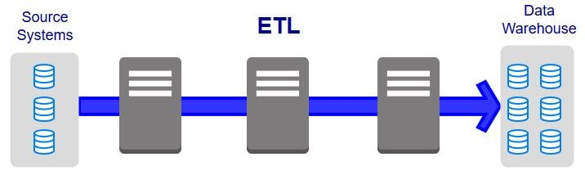

Diagram: The process of ETL

I have downloaded the dataset from Data.gov.in and cleaned some parts of the data and applied normal mathematical functions such as Average, Var, Stdev etc. as a part of ETL.

**Analysis on Dataset**

I have tried to fulfill the following objectives with my analyzing the data on Sex Ratio of India of the year 2001 and 2011.

1. Number of females per 1000 males across various zones of India like East, West, North and South.
2. Change in the number of females per 1000 men across India.
3. The number of states above the National Average in the year 2001 and 2011.
4. Ratio of rural sex ratio to urban sex ratio in union territories.
5. Child Sex Ratio (0-6 years) vs Population Sex Ratio in 5 States with major population in India.
6. Finding correlation between Literacy Rate and Sex Ratio of India using Spearman’s correlation coefficient to identify if the increasing literacy leads to increasing number of females per 1000 males.
7. Finding correlation between Decadal growth Rate and Sex Ratio change using Spearman’s correlation coefficient to identify if the increase in population has any correlation with the change in sex ratio.

**Analysis No.1:**

Number of females per 1000 males across various zones of India like East, West, North and South.

**Introduction:**

This analysis will help us identify the number of states with better sex ratio than the others and therefore lets us identify the reasons which may be the reason for the results.

**General Description:**

The analysis is basically a count of the number of females per 1000 males in various states and Union Territories of India.

**Specific Requirements, functions and formulas:**

The analysis requires the data of the number of females per 1000 males in the year 2001 and 2011.

We plot the graph of sex ratio of year 2001 and 2011 with respect to each state and analyze the states which are still lagging.

**Analysis Results:**

The above analysis gives us the graph of each state with their sex ratio in the year 2001 and 2011 and lets us see the differences.

**Visualization:**

**Analysis No: 2**

Change in the number of females per 1000 men across India.

**Introduction:**

This analysis lets us identify the change in the number of females per 1000 men across India from the year 2001 to 2011.

**General Description:**

This analysis requires the data of sex ratio of the year 2001 and 2011.It requires the difference between the numbers of females per 1000 males in the respective years 2001 and 2011.

**Specific Requirements, functions and formulas:**

The function used here is the difference between two numbers, i.e. the difference in the number of females per 1000 men between the years 2001 and 2011.

**Analysis Results:**

The result of the analysis gives us the increment or decrement in the number of females per 1000 males between the year 2001 and 2011 with Kerala having the maximum sex ratio across India in both the year 2001 and 2011.

The analysis lets us see the data according to the different zones of India namely East, West, North, South and for the Union Territories separately.

**Visualization:**

**Analysis No: 3**

The number of states above the National Average in the year 2001 and 2011.

**Introduction:**

This analysis provides us an insight on the states which are having better sex ratio than the average of India, which implies they must be sound in other factors also which leads to better Sex Ratio.

**General Description:**

This analysis basically tries to study the factors which lead to certain parts of the country having higher Sex Ratio than the other parts and the steps which may be taken to improve the conditions in the other states as well.

**Specific Requirements, functions and formulas:**

It requires the Sex Ratio data of India for the year 2001 ad 2011

This analysis requires the use of AVERAGE function and Sorting of data. We then display only the top 10 states however, the number may be varied.

The graph is plotted using a Pivot Table and Pivot Chart.

We can filter the data for the top 10 elements from the pivot chart.

**Analysis Results:**

**With the above analysis we found the number of states which are above the National Average namely:**

|  |
| --- |
| Andhra Pradesh |
| Chhattisgarh |
| Goa |
| Karnataka |
| Kerala |
| Manipur |
| Meghalaya |
| Mizoram |
| Odisha |
| Puducherry |
| Tamil Nadu |

**Visualization:**

**Analysis No: 4**

Ratio of rural sex ratio to urban sex ratio in union territories.

**Introduction:**

This analysis lets us examine the urban to rural Sex Ratio and identify the conditions responsible for the result.

**General Description:**

For performing this analysis, we will find the ratio of the rural to urban sex Ratio in the Union Territories and identify the one with better positive results.

**Specific Requirements, functions and formulas:**

This analysis requires the presence of the Sex Ratio data of the Union Territories for the respective years. We use mathematical division to find the rural to urban Sex Ratio in the Union Territories

We then use Pivot Chart and Pivot Table to plot the result.

**Analysis Results:**

The Output is as follows:

|  |  |  |
| --- | --- | --- |
|  | Ratio 2001 | Ratio -2011 |
| A & N Islands | 1.06 | 1.00 |
| Chandigarh | 0.78 | 0.84 |
| D & N Haveli | 1.23 | 1.27 |
| Daman & Diu | 0.60 | 1.57 |
| Lakshadweep | 1.03 | 1.01 |
| NCT of Delhi | 0.99 | 0.98 |
| Puducherry | 0.98 | 0.99 |

This suggests that the Sex Ratio in Rural parts is better than the urban parts in the Union Territories (which is surprising!)

**Visualization:**

**Analysis No: 5**

Child Sex Ratio (0-6 years) vs Population Sex Ratio in 5 States with major population in India.

**Introduction:**

This analysis lets us compare the Sex Ratio between the ages 0-6 years to that of the adults and makes us to find if the ratio remains constant or changes with age and the factors behind.

**General Description:**

The analysis of the Child Sex Ratio and Population Sex Ratio lets us identify any changes that may exist and also allows us to consider factors like medical availability etc. available which is very crucial for longer life and hence affect the Population Sex Ratio.

**Specific Requirements, functions and formulas:**

This analysis requires the data of Child Sex Ratio and Population Sex Ratio for the year 2001and 2011.

We then use advanced feature of pivot table of using data from multiple sources to be able to plot a pivot table having data from both the tables of Child Sex Ratio and Population Sex Ratio.

Then, a graph is plotted accordingly.

**Analysis Results:**

The analysis gives us the corresponding Child Sex Ratio and Population Sex Ratio for the year 2001 and 2011 for the 5 states having the major population in India.

|  |  |  |  |  |
| --- | --- | --- | --- | --- |
| Row Labels | Sum of CSR Total - 2001 | Sum of CSR Total - 2011 | Sum of Total - 2001 | Sum of Total - 2011 |
| Bihar | 942 | 935 | 919 | 918 |
| Madhya Pradesh | 932 | 918 | 919 | 931 |
| Maharashtra | 913 | 894 | 922 | 929 |
| Uttar Pradesh | 916 | 902 | 898 | 912 |
| West Bengal | 960 | 956 | 934 | 950 |
| Grand Total | 4663 | 4605 | 4592 | 4640 |

**Visualization:**

**Analysis No: 6**

Finding correlation between Literacy Rate and Sex Ratio of India using Spearman’s correlation coefficient to identify if the increasing literacy leads to increasing number of females per 1000 males.

**Introduction:**

This analysis helps us to identify the possible correlation between the Literacy Rate and Sex Ratio of India. We will use the Spearman’s correlation coefficient for the same.

The Spearman rank correlation coefficient, rs, is the [nonparametric](https://www.statisticshowto.datasciencecentral.com/parametric-and-non-parametric-data/)version of the [Pearson correlation coefficient](https://www.statisticshowto.datasciencecentral.com/probability-and-statistics/correlation-coefficient-formula/). Your data must be [ordinal](https://www.statisticshowto.datasciencecentral.com/ordinal-numbers/), [interval](https://www.statisticshowto.datasciencecentral.com/interval-scale/)or [ratio](https://www.statisticshowto.datasciencecentral.com/ratio-scale/). Spearman’s returns a value from -1 to 1,

where:  
+1= a perfect positive [correlation](https://www.statisticshowto.datasciencecentral.com/probability-and-statistics/correlation-analysis/) between ranks  
-1= a perfect negative correlation between ranks  
 0 = no correlation between ranks.

**General Description:**

This analysis will use the Spearman’s correlation coefficient to find the possible correlation between Literacy Rate and Sex Ration to see if one increases with the other or not.

**Specific Requirements, functions and formulas:**

This analysis requires the pre-requisite knowledge of the use of Spearman’s correlation coefficient and what its value ranges suggest for the data.

The formula used is:

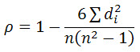

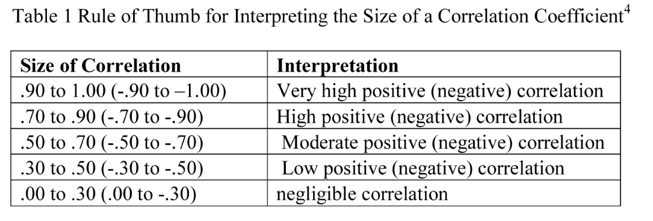

Pivot table and pivot Table are used to implement the same.

**Analysis Results:**

The output received shows a small positive correlation between Literacy Rate and Sex Ratio, which means that with the increase in Literacy Rate, the Sex Ratio also increases which is a good indicator.

|  |  |
| --- | --- |
| SUM | 6732 |
| 6*SUM | 40392 |
| (N³-N) | 42840 |
|  | 0.9429 |
| R | 0.05715 |
|  | POSITIVE CORRELATION |

**Visualization:**

**Analysis No: 7**

Finding correlation between Decadal growth Rate and Sex Ratio change using Spearman’s correlation coefficient to identify if the increase in population has any correlation with the change in sex ratio.

**Introduction:**

This analysis helps us to identify the possible correlation between the Decadal Growth Rate and Sex Ratio of India. We will use the Spearman’s correlation coefficient for the same.

**General Description:**

This analysis will use the Spearman’s correlation coefficient to find the possible correlation between Decadal Growth Rate and Sex Ration to see if one increases with the other or not.

**Specific Requirements, functions and formulas:**

This analysis requires the pre-requisite knowledge of the use of Spearman’s correlation coefficient and what its value ranges suggest for the data. The formula used is



**Analysis Results:**

The output received shows a negative correlation between Decadal Growth Rate and Sex Ratio, which means that with the increase in Decadal Growth Rate, the Sex Ratio also decreases. The graph plotted shows the rank of different states according to their decadal growth rate and Sex Ratio.

|  |  |
| --- | --- |
| SUM | 8632 |
| 6(D^2) | 51792 |
| (N^3-N) | 42840 |
|  | 1.2090 |
| R | -0.2089 |
|  | NEGATIVE CORRELATION |

**Visualization:**

**LIST OF OTHER FUNCTIONS USED**

1. **VBA MACROS:**

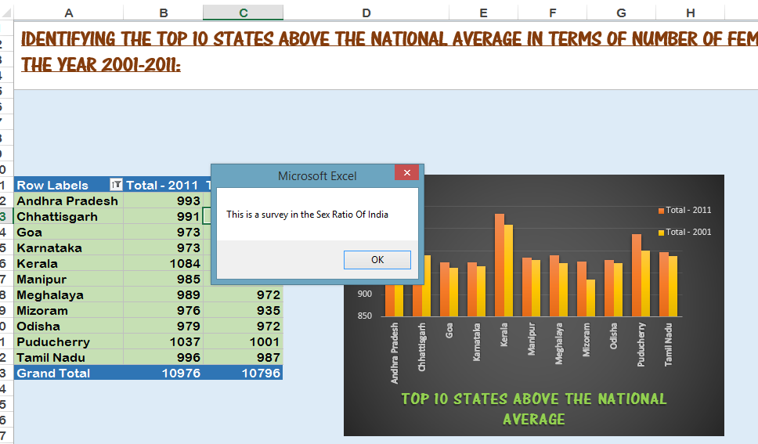

1. **COMBO CHART:**

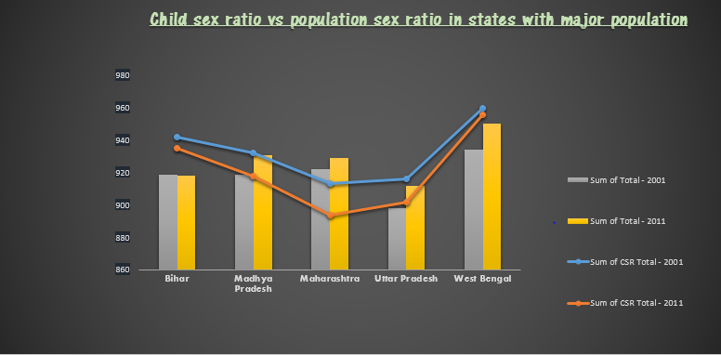

1. **PIVOT CHART AND PIVOT TABLE:**

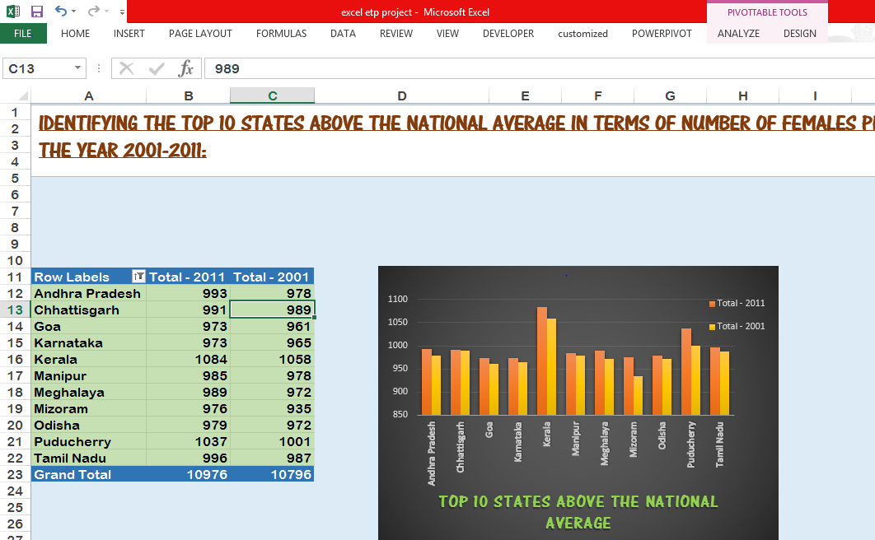

1. **MATHEMATICAL FUNCTIONS**

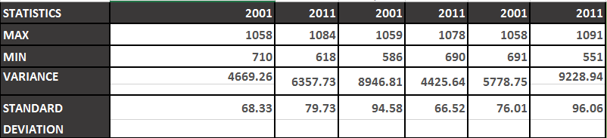

1. **DATA MODELS TO CREATE RELATIONSHIPS BETWEEN TABLES**

A Data Model allows you to integrate data from multiple tables, effectively building a relational data source inside an Excel workbook. Within Excel, Data Models are used transparently, providing tabular data used in PivotTables and PivotCharts. A Data Model is visualized as a collection of tables in a Field List, and most of the time, you’ll never even know it's there.

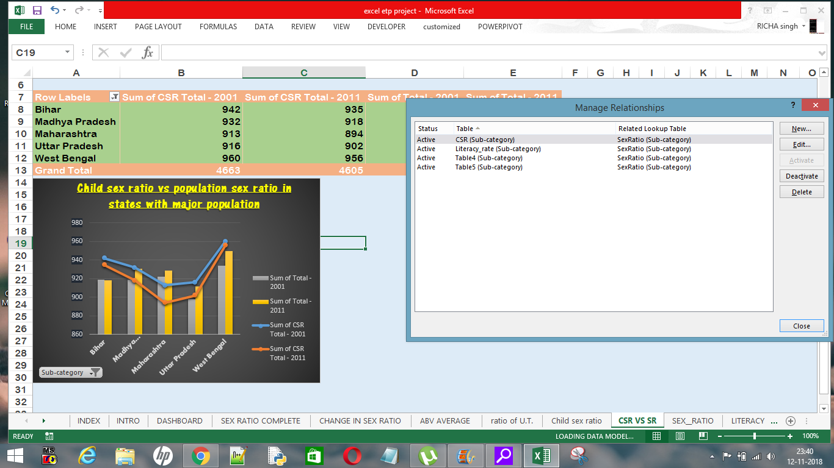

1. **USE OF POWERPIVOT AND DAX FUNCTIONS TO CALCULATE PERCENTAGE CHANGE BETWEEN CHILD SEX RATIO AND SEX RATIO**

Power Pivot is an Excel add-in you can use to perform powerful data analysis and create sophisticated data models. With Power Pivot, you can mash up large volumes of data from various sources, perform information analysis rapidly, and share insights easily.

In both Excel and in Power Pivot, you can create a Data Model, a collection of tables with relationships. The data model you see in a workbook in Excel is the same data model you see in the Power Pivot window. Any data you import into Excel is available in Power Pivot, and vice versa.

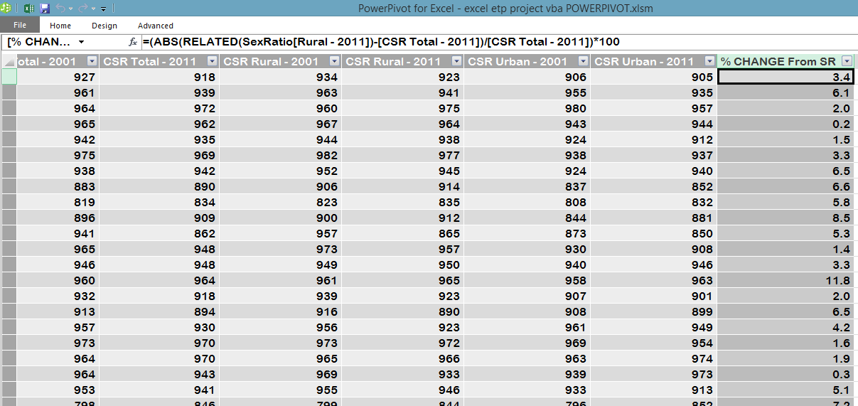

**List of Analysis with results**

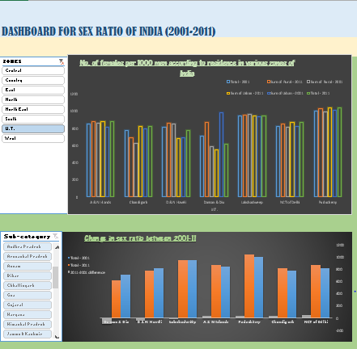

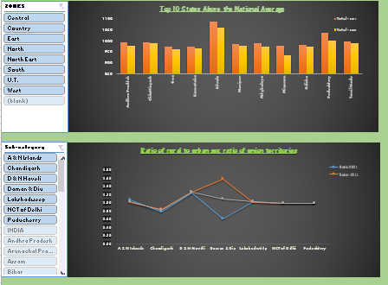

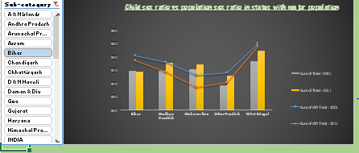

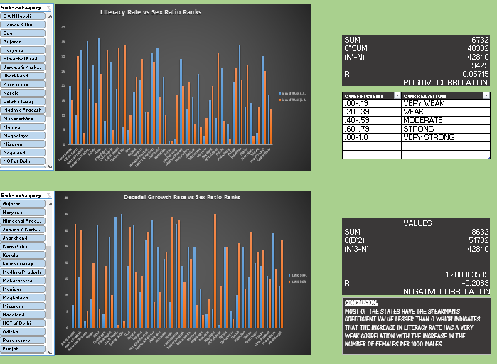

**Future scope**

The data analysis on the Sex Ratio of India has a lot of future scope, such as:

1.) To help to maintain the harmonious balance of the sex ratio in the society.

2) To educate the people regarding the adverse effect of the female foeticide in society.

3.) To take the strict legal measures to eradicate this social evil.

4.) To carry an intensive behavioral study on the various segment like student, researchers, medical professionals, educationists, government and non-government officials, judicial officer, legislative members, religious preachers.

5.) To examine the female foeticide problem in multiple views like the social evil, e.g. dowry women unemployment, exploitation, education standard of girl child, early marriages and arrange marriages system and prejudicious bent of mind of the people toward the son preference.

6.) Determining the Target Group: A campaign to addressed sex selection has to conceptualize the problem in terms of demand and supply in order to determine the target group.

**References**

1. <https://www.statisticssolutions.com/correlation-pearson-kendall-spearman/>
2. <https://data.gov.in/>
3. <https://en.wikipedia.org/wiki/List_of_states_and_union_territories_of_India_by_sex_ratio>
4. <http://niti.gov.in/content/sex-ratio-females-1000-males>
5. <https://www.unfpa.org/resources/characteristics-sex-ratio-imbalance-india-and-future-scenarios>
6. https://www.mapsofindia.com/answers/india/state-highest-sex-ratio/

**Bibliography**

1. **Data.gov.in**
2. [**http://shodhganga.inflibnet.ac.in**](http://shodhganga.inflibnet.ac.in)
3. [**www.ncbi.nlm.nih.gov**](http://www.ncbi.nlm.nih.gov)
4. [**www.jagranjosh.com**](http://www.jagranjosh.com)
5. [**www.unfpa.org**](http://www.unfpa.org)
6. **www.researchgate.net**